Welcome to

Rutherglen High School

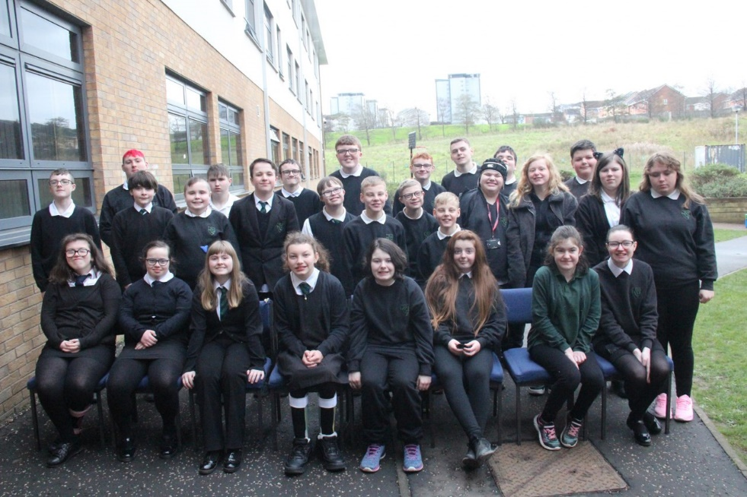

In this pack includes

* All about Rutherglen
* How to keep up to date with Parents Portal
* School information for pupils
* Plan of the school
* Where to buy school uniforms
* School Handbook
* Pupil information pack **(to be completed and handed back)**

Rutherglen High School

We aim to provide a range of learning experiences, which meet the needs of all our learners. Working together in partnership: school staff, parents and our partner agencies can help us achieve this goal.

Rutherglen High School opened in August 1999 and is a non-denominational and co-educational school. The school is part of the Cathkin Learning Community and has formed strong links within local community.

The school provides education for 120 pupils and is currently located in Langlea Road in Cambuslang. All pupils attending Rutherglen High School have a range of Additional Support Needs and have an Additional Support Plan or Co-ordinated Support Plan to assist the school in the planning a curriculum which supports pupils in achieving their potential. Support for the pupils is provided in the form of smaller class sizes ( maximum 10) with allocated staff to provide continuity and security.

Pupils are supervised at the morning interval and lunchtime and are provided with assistance with personal care if required.

Rutherglen High has a strong link with Glasgow Clyde College (Langside and Cardonald Campus), New Lanarkshire college, New College Lanarkshire (Motherwell Campus) and City of Glasgow college (Riverside and John Wheatly Campus). Through our extensive Work Experience programme, good partnership has been established with local employers.

We are a Rights Respecting School, a Health Promoting School and an Eco School, Fund raising for charity and the promotion of Fairtrade are an integral part of the school Ethos. To date we have gained our Gold Award in Health Promoting School Awards and have maintained Eco School status since 2006. We are also a Rights Respecting School (Level 1) and have a Bronze Level of the Enhanced visual School Award.

Dear Parent/Carer

**parentsportal.scot / S1 Pupils**

Parentsportal.scot is a new digital service to help replace the traditional ‘school bag run’ by providing direct communication to parents and carers through a growing suite of online services. Through parentsportal.scot parents and carers will be able to grant permissions for school trips, view school lunch menus, view attendance, complete the annual data check, book parents evening and link directly to ParentPay to make payment for school meals, to name but a few.

We would ask that you link your S1 child to their secondary school in parentsportal.scot **in August** when your child is registered at Rutherglen High. If you have previously linked to your child’s primary school, then this link is now broken and you need to log onto parentsport.scot and ‘add child’ selecting your child’s secondary school.

If you are a new parent to South Lanarkshire Council, or previously didn’t link to your child’s primary school we would ask you do this for their time a secondary school. To access parentsportal.scot go to <https://parentsportal.scot/home/> . If you have a mygovscot my account click the link to Sign In or if you don’t have a mygovscot my account click the link to register for a mygovscot my account. Alternatively use the QR codes at the bottom of the letter to download the parentsportal.scot APP.

Once registered you will be prompted to Link Your Child. To be able to link your child you will be asked to provide details relating to your child, the school they attend and your relationship with them. Once the details are found and matched you will be sent a security code to either your mobile number or email address registered in the school. The security code is to provide additional security before your child’s record is linked. Your request to link your child will then be sent to your child's school for approval. You will then be notified of the decision to approve the link on your email.

Once your child/children are linked to their school you will start to receive communications from the school via parentsportal.scot and over time will become your one-stop-shop to everything to do with your child and their school.

Yours faithfully

**David Hinshelwood**

**Support Services Manager**

**Uniforms**

We no longer hold school uniforms in school to buy. We have competitively sourced two suppliers that would be able to supply you with school ties and uniform with the school logo.

Please note that the school no longer deals with prices or products changes it is the responsibility of the companies below, but they have been very supportive in price matching where they can. (depending on suppliers)

**Blossoms Schoolwear – East Kilbride Town Centre**

Bought online or order/collect in store

<https://blossomsschoolwear.com/secondary-school-uniform/south-lanarkshire-high-schools/rutherglen-high/>

**Scotcrest**

These uniforms will be **made to order** and can be collected in the Hamilton shop or couriered to the home address. The pupils can try on standard blazers in store to get their size.

<https://scotcrestschools.co.uk/Find-Your-School/South-Lanarkshire/Rutherglen-high>

Scotcrest Uniforms Hamiton

41 Quarry Street

Hamiton

ML3 &AH